what is the difference between compiler? And interpreter,

Your compiler takes the whole code that you have written. You write multiple instructions in a language, like C, C++, Java or Python. And then you use a compiler to convert this whole code into a low-level code that your machine can understand.
Interpreter does this line by line. It does not take the whole code and then generate a binary file or an executable file. Interpreter does this conversion line by line. It takes your code line by line and converts it into a code that a machine can understand.

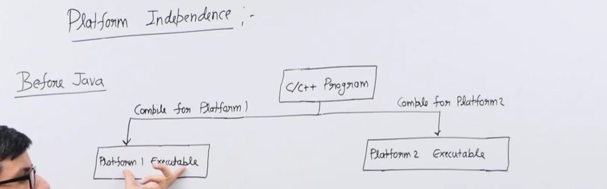

Java is platform independent. Let us first define what a platform is. A platform is a combination of an operating system and architecture that you are using. For example, Windows + Intel is a platform, Linux + Intel is a platform, and Windows + AMD is a platform.
Before Java, programming used to happen this way: You write a C or C++ program. If you want to run this program on one platform, you compile it using a compiler that generates an executable for a particular platform.
The compiler generates the executable, and then you run it. The executable generated for one platform cannot be used on another because different platforms have different executable formats. If you want to run this program on another platform, you will need a compiler for that platform, and then you will have to compile the program using that compiler. This will generate the executable code for that particular platform.

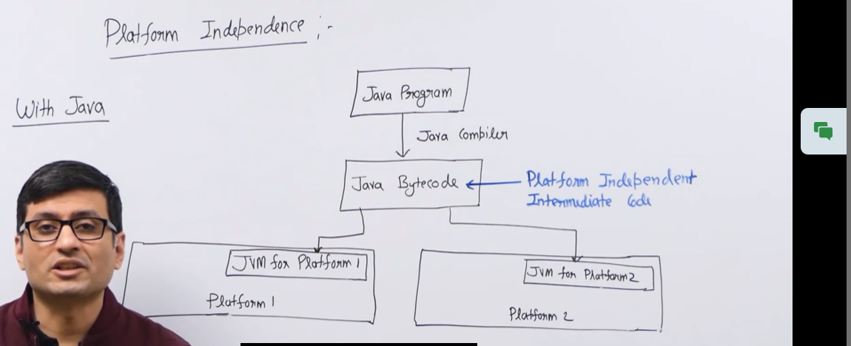

In Java, when you compile a program, your compiler converts your program into an intermediate code called Java bytecode. This bytecode can run on any platform that has a platform-specific JVM or Java Virtual Machine pre-installed.
Now, what is JVM? JVM stands for Java Virtual Machine. This is a machine-specific software responsible for running bytecode on that machine. The platform-specific software takes the general bytecode and converts it into machine-specific or platform-specific instructions.
This JVM is different for Linux, different for Windows, and is pre-installed on these machines. As a programmer, you do not have to worry about machine-specific requirements. You simply write your program once, compile it, generate the bytecode, and it can run on any platform.
That is why Java is called platform-independent.
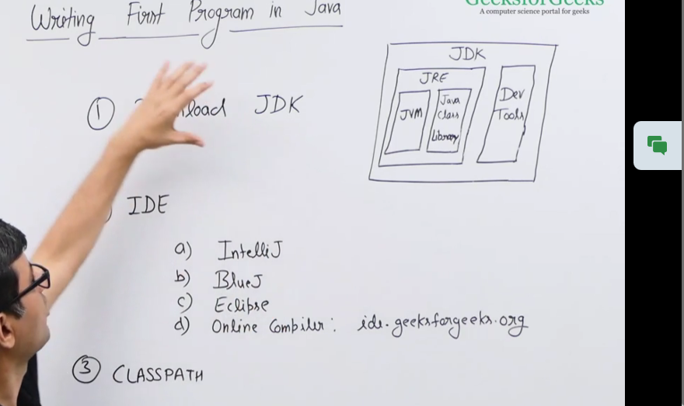
JRE, or Java Runtime Environment, contains the JVM and Java class libraries, which are standard libraries required to run Java programs.
JDK contains JRE and development tools. What are development tools? Development tools are the tools required for software development, such as the Java compiler, Java debugger, and Java document generator. There is a long list of tools included in the JDK.
Classpath is the variable where you specify the root directories of all the projects that you want to run or use in your Java software.

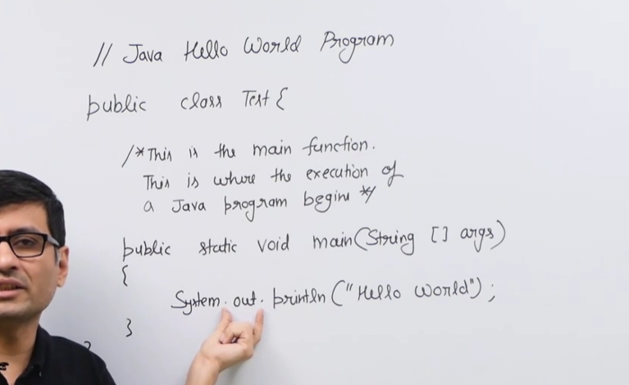
Public: This main method becomes accessible from everywhere, especially when you run this Java program. JVM needs to run this program outside the package and outside the class, so that is why we make it public.
Static: static methods are special methods that can be called without creating an object. The main method is always made static because JVM does not want to create an object of this class just to run this method. Instead, it simply calls the main function directly, which is why it is static.
Void: This is the return type of main. Java decided to use void as the return type of main, which is different from C and C++, where the return type is ideally an int.
Arguments: This refers to an array of strings that are passed to the main function. When you write a function, it can receive arguments, and Java decided to have arguments as an array of strings so that a set of strings can be passed as command-line parameters. When running an application via the command line, you can specify special parameters for the application to use.

Typically, we do not use this array named "args." The name of the array can be anything.

Inside this main function, there is a line to print "Hello, World" on the screen. This line works as follows:

- System is a standard Java class.
- Out is an object inside this class, specifically an object of the PrintStream class, which is used to print something on the screen or the standard output device.
- Println is a method inside the PrintStream class, called on the out object.
- "Hello, World" is just a string that we want to print inside the main method. You can write anything you want to be displayed inside this function.

Let me know if you need any further modifications!

